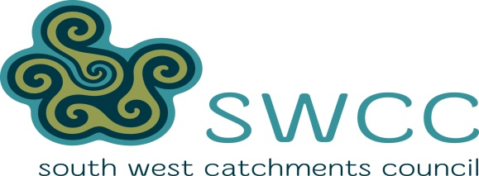 

SWCC’s South West Community Groundworks Program offers grants **between $5,000 and $25,000** to the Landcare community to address NLP priorities through on-ground projects and related activities. This includes projects that protect biodiversity and sites of ecological value, support sustainable management of agriculture and aquaculture, increase the skills and knowledge of the local community in NRM and other priority activities identified within local and regional NRM plans and strategies.

Grants are targeted at local community groups and individuals that can successfully deliver NRM projects. Applications can be submitted by individual farmers and land managers, farmer / production groups, industry groups, Aboriginal groups, ‘friends of’ groups, Landcare and NRM organisations or other community groups within the South West NRM region.

Applicants must maintain sufficient insurances to cover their liability in conducting activities funded in part or full through the project and its obligation to indemnify the Australian Government, the South West Catchments Council, their offices, employees and agents. Insurances would include but may not be limited to public liability insurance, workers’ compensation insurance (where employment of others is involved) and personal accident insurance for volunteers, if applicable. Where worker’s compensation insurance is not applicable, proof of alternative insurance (personal accident and/or income protection) may be required.

Project activities must show how they meet the following NLP Priorities:

* Protection and restoration of ecosystem function, resilience and biodiversity; appropriate management of invasive species which threaten ecosystems, habitats or native species.
* Sustainable management of agriculture and aquaculture to conserve and protect biological diversity and reduce greenhouse gas emissions and increase carbon stored in soil.
* Build community awareness of biodiversity values, skills, participation and knowledge, including Indigenous knowledge and participation, to promote conservation and sustainable use of biological diversity.

**APPLICATION CLOSE 17TH JUNE 2016. Contact the Landcare Office NOW for further information. Phone 9863 4225 or A/Hrs on 0429612447**